
Endometriosis Roundtable

2 October 2025
Identifying best practice for supporting employees experiencing reproductive health challenges in the workplace.
Addressing Parliamentary Select Committee into Endometriosis Recommendation 18.

Summary Report

Contents
Acknowledgement of Country 3
1 Executive Summary 4
Next steps for the South Australian government include: 4
2 Context 6
3 Endometriosis roundtable summary 7
3.1 Expert panel discussion and Q&A 7
3.2 Interactive workshop 8
4 Actions to drive change 10
4.1 Actions for workplaces 10
4.2 Actions at the systems-level 10
5 The way forward 11
Contact the Office for Women 11
6 Appendix 1: speakers and panellist details 12
6.1 Speakers 12
6.2 Panellists 13
7 Appendix 2: attendee responses 14
8 Appendix 3: Bar Chart Data 16
8.1 Bar Chart Question 1 16
8.2 Word Cloud Question 1 16
8.3 Bar Chart Question 2 17
8.4 Word Cloud Question 2 17
9 Appendix 4: resources, research papers and references 18
9.1 Resources 18
9.2 Research Papers 18
9.3 References cited 19

Acknowledgement of Country
The Government of South Australia acknowledges Aboriginal peoples as the state’s first peoples and nations and recognise them as the traditional owners, occupants and ongoing custodians of the lands and waters in South Australia. We further pay our respects to their Elders past and present and recognise the vital role they play in supporting their communities.
We further acknowledge and respect the leadership and profound commitment of Aboriginal women in improving the lives of their communities, and those of the broader South Australian community, through their tireless advocacy. Aboriginal women leaders play an important role in advancing the interests of girls and women through generously sharing wisdom and culture and through their continued advocacy over years, decades and lifetimes.

1 Executive Summary
Endometriosis affects about 1 in 7 Australian women and costs the Australian economy up to $9.7 billion each year. Hospitalisations for endometriosis have doubled in young women aged 20–24 over the past decade, showing the growing need for early diagnosis, better treatment, and more support in workplaces. A Parliamentary Select Committee on Endometriosis was established in South Australia in 2024 to investigate the prevalence, barriers to diagnosis and treatment, effectiveness of current supports, employment impacts, education, and ongoing research related to endometriosis.
The Committee's Final Report included a recommendation that “the State Government facilitate a stakeholder forum inviting members of leadership and management teams, from both private and public sectors and unions, to discuss and exchange experiences and ideas in dealing with employees who have reproductive health challenges, including endometriosis.” On 2 October 2025, the Honourable Katrine Hildyard MP, Minister for Women, hosted an Endometriosis Roundtable facilitated by the Office for Women, Department of Human Services, South Australian Government.
The roundtable event was attended by more than 40 leaders from the private and public sectors and unions who discussed best practice for supporting employees experiencing reproductive health challenges in the workplace. Key themes for areas of change in the workplace were identified during the panel discussion, Q&A and group table discussions including:
- leadership — leaders to role model best practice and support employees, champions in the workplace and psychological safety for people experiencing symptoms.
- flexible working practices and flexibility in the workplace — including flexible working hours and breaks, job sharing, working from home options, small or low-cost accommodations, staff across each other’s roles to act as backup if required.
- workplace policies — one-time medical certificates, unlimited sick leave as a trust enabler, leave pools, and specific reproductive leave.
- education — incorporating endometriosis awareness into leadership and management training, whole of organisation training, education to help people experiencing symptoms and for the medical profession to enable earlier diagnosis.
- culture change — including addressing dismissal of symptoms, particularly with endometriosis being an unpredictable and ‘invisible’ condition, addressing stigma and the need for conversations about periods, pain, and invisible health conditions in the workplace.
- system-level change — cross-sector engagement on policies and best practice.

Next steps for the South Australian government include:
- development of a suite of best practice education and awareness raising materials such as fact sheets and resources that workplaces can use to educate and raise awareness among leaders and staff.
- collaboration with industry peak bodies such as the South Australian Business Chamber and unions to promote awareness raising and education activities, for example the EndoThrive program.
- continuing to raise awareness about the need for and importance of addressing the impact of endometriosis in the workplace by promoting this Summary Report, the outcomes of the roundtable and resulting developments.
- collaboration across government to ensure the findings and recommended actions from the Roundtable are aligned with the outcomes of the other recommendations and delivered through a coordinated whole of system approach.

2 Context
The State Government’s Women’s Equality Blueprint 2023–2026 includes four priority areas to help achieve South Australia’s vision as a fair and inclusive state, in which women and girls can equally and actively participate in the economy and all aspects of community life. The priority areas are Safety and Security; Leadership and Participation; Economic Wellbeing and Health.
The Leadership and Participation priority seeks to rectify the current situation where women continue to experience lower levels of workplace participation than men and remain significantly underrepresented in leadership and management roles in many workplaces and industries. Taking action to address issues that prevent women from participating in the workplace and progressing into leadership roles, such as chronic health conditions like endometriosis, is key to achieving equality, and to our State’s economic ambition.
The Health priority focusses on helping to achieve equality by providing women with equitable access to universal health services and the necessary supports to maintain a healthy life. This includes being able to access support for health issues women may encounter across their lifetime including reproductive health issues such as endometriosis.
Endometriosis seriously impacts work and the daily lives of women who experience it. Endometriosis occurs when body tissue similar to the lining of the uterus, the endometrium, grows in other parts of the body, usually in the pelvis causing inflammation, severe pain, infertility; and can have a significant impact on quality of life. It is a progressive and chronic condition that costs the Australian economy up to $9.7 billion each year — mostly due to lost productivity.
Recognising the significant amount of time most women spend at work, and the impact endometriosis has on workforce participation, addressing endometriosis in the workplace was a key recommendation by the Parliamentary Select Committee on Endometriosis that was established in South Australia in 2024 and chaired by Catherine Hutchesson, MP. The Select Committee explored for the first time how widespread endometriosis is in the South Australian community. It also examined the current treatment and supports available, how education and awareness can be improved and how employers can best support employees who have this condition. The committee found this suffering is widespread — its impacts include infertility, disruptions in workforce participation, and negative effects on mental health and emotional wellbeing.
The Final Report of the Select Committee on Endometriosis was released on 19 March 2025 and provided 20 recommendations including Recommendation 18 that “the State Government facilitate a stakeholder forum inviting members of leadership and management teams, from both private and public sectors and unions, to discuss and exchange experiences and ideas in dealing with employees who have reproductive health challenges, including endometriosis.”
The Final Report outlined the rationale behind the recommendation: “having this forum will inform both private and public sectors of best practices in dealing with employees with reproductive health challenges, including endometriosis. Moreover, it will help the State Government determine support mechanisms for both public and private sectors to create or maintain supportive workplaces.”

3 Endometriosis roundtable summary
The Honourable Katrine Hildyard MP, Minister for Women hosted the roundtable event on Thursday 2 October 2025 at the Hotel Grand Chancellor Adelaide. The roundtable event was facilitated by the Office for Women, Department of Human Services and the South Australian Government. It focused on discussing and exchanging experiences and ideas in supporting employees who have reproductive health challenges, including endometriosis. The aims of the roundtable event were to:
- facilitate discussion among attendees about best practice for supporting employees who are experiencing reproductive health challenges, including endometriosis.
- equip attendees with examples of policies and practices that can be utilised in their workplaces.
The event included addresses from: Minister for Health and Wellbeing, the Honourable Chris Picton MP; Parliamentary Select Committee on Endometriosis Chair, Catherine Hutchesson MP; Emcee Libby Trainor Parker; an expert panel with a Q&A session and an interactive workshop with attendees.
More than 40 attendees consisted of members of leadership and management teams from both private and public sectors and unions.

3.1 Expert panel discussion and Q&A
Libby Trainor-Parker facilitated a panel discussion and Q&A session with experts and lived experience advocates Catherine Hutchesson MP, Chair of Parliamentary Select Committee on Endometriosis; Deanna Wallis, Endometriosis Australia Ambassador; Dr Beck O’Hara PhD, Endometriosis researcher at Flinders University and Tayla Willliams, Thunderbirds player and lived experience advocate. The panel discussion centred around the challenges of working while experiencing endometriosis, an overview of current research about endometriosis in the workplace and examples of what has worked in terms of being supported at work.
The key themes arising from the panel discussion and Q&A included the following:

Education is essential.
People with endometriosis need improved awareness of symptoms; medical professionals require training and ongoing education; workplaces benefit from understanding the condition and its impact.

Dismissal and disbelief are common.
Women's pain is often normalised or dismissed; endometriosis is misunderstood as just ’bad periods;’ workplace consequences include missed promotions, job loss, and presenteeism; listening and believing sufferers is crucial.

Stigma and shame persist.
Talking about periods remains taboo, especially among older generations; normalising menstrual health discussions can help reduce stigma and support conversations about endometriosis.

Resilience of those affected.
People with endometriosis endure years of pain and disbelief, developing strong resilience that can be a valuable asset in the workplace when properly supported.

Flexibility and accommodations matter
Each person’s experience is unique; small, cost-effective adjustments (for example flexible hours, ergonomic furniture, rest areas) can significantly improve workplace support.

Leadership and economic impact
Managerial support and workplace culture shape individual experiences; lack of support leads to reduced hours or job loss, contributing to gender employment gaps and economic cost.

3.2 Interactive workshop
The interactive workshop was facilitated by Libby Trainor-Parker who invited contributions from attendees about best practice for supporting employees who are experiencing reproductive health challenges. Attendees were asked to focus on best practice themes identified in the Select Committee Report which included:
- leadership awareness and culture
- policies and practices
- education and Training
- equity and Inclusion
- collaboration and Innovation
The key themes and recommendations from the interactive workshop included:

Leadership and culture
Leaders play a critical role in shaping workplace culture around reproductive health by role modelling, fostering psychological safety and engaging in two-way conversations. Leadership education and empathy are essential, and men must be included in the dialogue.

Policy, practice and industrial conditions
Organisations should offer reproductive health leave/unlimited sick leave to support employees requiring additional leave, flexible work arrangements, and health and wellbeing rooms. Support structures like women’s health committees, culture champions and clear documentation help embed these policies.

Education and training
Managers and HR teams need structured, interactive training to understand endometriosis, compassionately support staff and navigate conversations. Education should include case studies, multilingual resources and be integrated into leadership development.

Equity and inclusion
Workplace support must be inclusive of gender-diverse and neurodiverse employees. Co-designing policies, translating materials and recognising diverse experiences ensures accessibility and fairness. Chronic health plans and data collection can help tailor support.

Stigma reduction and normalisation
Early education (for example in schools), open conversations, and visible support (for example free period products, accessible uniforms) help reduce stigma and normalise pain-related conditions in the workplace.

Collaboration and Innovation
Cross-sector partnerships (for example with unions, Employee Assistance Programs (EAPs), health organisations) and shared solutions can drive systemic change. Best practice workplaces offer flexible leave, inclusive recruitment, and ambient support, with recognition programs like ‘Employer of Choice’ or endo-friendly accreditation.

4 Actions to drive change
Through the panel discussion, Q&A, interactive workshop and audience participation via Slido (see Appendix 2) the following opportunities have been identified for workplaces and at a systems level.

4.1 Actions for workplaces

Embed flexibility into work practices
- Offer flexible work hours and remote work options, especially during health flare-ups.
- Allow compassionate flexibility in scheduling meetings, training and deadlines.
- Shift from rigid attendance models to outcome-based performance.

Foster supportive leadership and culture
- Train managers to lead with empathy and understanding of chronic conditions.
- Encourage open conversations about reproductive health and invisible pain.
- Promote EAPs and ensure leaders are visible advocates for wellbeing.
- Appoint staff-led champions to advocate for reproductive health and wellbeing.
- Encourage peer support and visible leadership on inclusive practices.

Strengthen education and awareness
- Run seminars, presentations and informal awareness campaigns.
- Include reproductive health topics in leadership development and staff training.
- Use case studies and real stories to build empathy and understanding.

Improve leave policies and entitlements
- Introduce paid menstrual and menopause leave and uncapped sick leave.
- Create reproductive health leave categories that do not require excessive proof.
- Consider one-time medical certificates to reduce administrative burden.

Provide practical support and resources
- Stock free menstrual products in all staff and client bathrooms.
- Ensure access to inclusive uniforms, accessible toilets and health rooms.
- Consult with employees to develop chronic health plans tailored to individual needs.

4.2 Actions at the systems-level

Government leadership
- Provide resources, policy and sector-wide guidance.
- Use of social media and public education (for example in schools) to reduce stigma and normalise pain-related conditions.
- Reviewing awards and legislation to embed flexibility and support across sectors.

Cross-sector collaboration
- Partnerships with unions, health organisations and EAPs to support innovation and shared learning.

5 The way forward
The event has highlighted a number of opportunities for workplaces and for government including:
- development of a suite of best practice education and awareness raising materials such as fact sheets and resources that workplaces can use to educate and raise awareness among leaders and staff.
- collaboration with industry peak bodies such as the South Australian Business Chamber and unions to promote awareness raising and education activities such as the EndoThrive program.
- continuing to raise awareness about the need for and importance of addressing the impact of endometriosis in the workplace by promoting this Summary Report, the outcomes of the roundtable and resulting developments.
- collaboration across government to ensure the findings and recommended actions from the Roundtable are aligned with the outcomes of the other recommendations and delivered through a coordinated whole of system approach.

Contact the Office for Women
Email DHSOFWGenderEquity@sa.gov.au.

6 Appendix 1: speakers and panellist details

6.1 Speakers

The Honourable Katrine Hildyard MP, Minister for Women


The Honourable Chris Picton MP, Minister for Health and Wellbeing


Catherine Hutchesson MP, Chair of Parliamentary Select Committee into Endometriosis

6.2 Panellists

Libby Trainor Parker
Event facilitator, health advocate, MC, speaker, teacher and award-winning cabaret artist and author of Endo Days.


Deanna Wallis
Endometriosis Australia Ambassador.

Dr Beck O’Hara PhD
Endometriosis researcher at Flinders University.

Tayla Williams
Adelaide Thunderbirds Player and lived experience advocate.

7 Appendix 2: attendee responses
The attendees were invited to respond to two questions via Slido:
Question 1: When it comes to supporting employees in the workplace with reproductive health challenges, including endometriosis, what is working and what are some of the best practice examples you have seen?

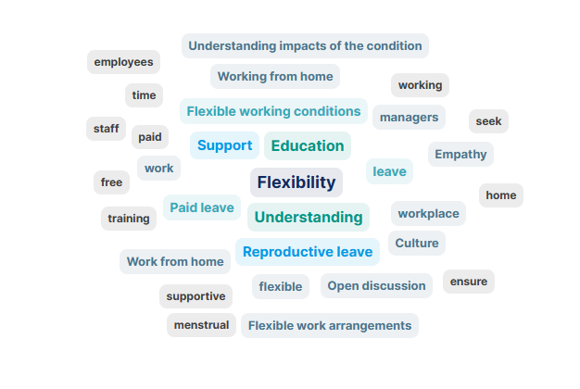

Question 2: What is one thing that you will implement in your workplace following today’s session?

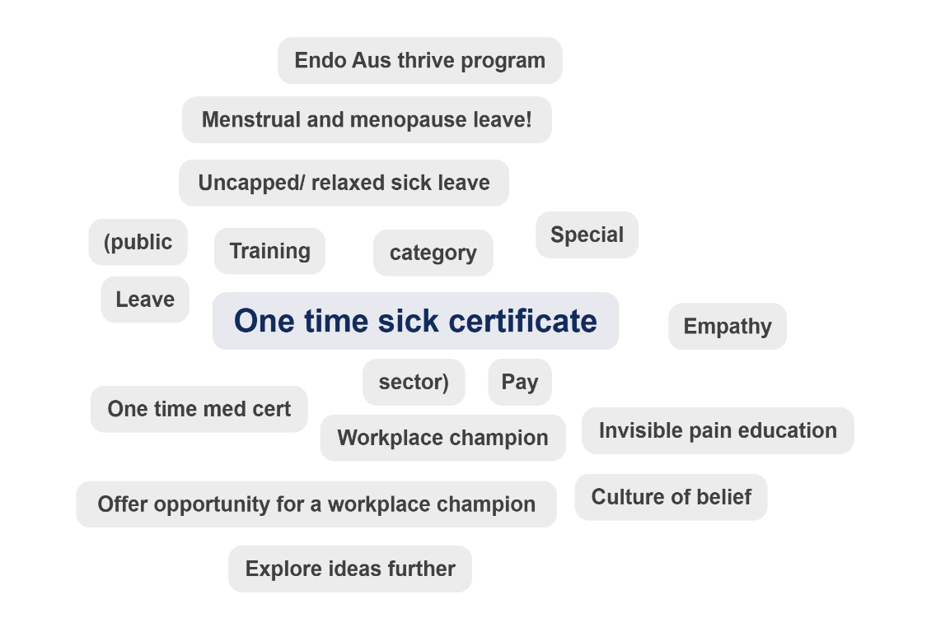

8 Appendix 3: Bar Chart Data

8.1 Bar Chart Question 1
When it comes to supporting employees in the workplace with reproductive health challenges, including endometriosis, what is working and what are some of the best practice examples you have seen?
Response Category | Number of Responses
Flexibility in work arrangements | 20
Supportive leadership and culture | 15
Leave entitlements and reproductive health policies | 10
Empathy, kindness and understanding | 10
Education and awareness | 8
Practical support and resources | 5

8.2 Word Cloud Question 1
The most common terms in attendee’s responses were:
- flexibility
- understanding
- education
- support
- reproductive leave.
Other common terms visible in the word cloud include:
- understanding impacts of the condition
- working from home
- paid leave
- empathy
- open discussion
- training
- culture.

8.3 Bar Chart Question 2
What is one thing that you will implement in your workplace following today’s session?
Response Category | Number of Responses
Leave policy improvements | 5
Leadership and cultural change | 4
Education and awareness | 3
Workplace champions and advocacy | 2

8.4 Word Cloud Question 2
The most common term in attendee’s responses was one time sick certificate.
Other common terms visible in the word cloud include:
- Endo Aus thrive program
- Menstrual and menopause leave
- Uncapped/relaxed sick leave
- Training
- Empathy
- Workplace champion
- Invisible pain education
- Culture of belief
- Offer opportunity for a workplace champion
- Explore ideas further.

9 Appendix 4: resources, research papers and references

9.1 Resources
Final Report of the Select Committee on Endometriosis
saselectcommitteeonendometriosisreport.pdf
Endometriosis Australia Resources
Endometriosis downloads and resources — Endometriosis Australia
Endometriosis Australia: EndoThrive Workplace Accreditation Program
Workplace support for Endometriosis — Endometriosis Australia

9.2 Research papers
Endometriosis and the workplace: Lessons from Australia's response to COVID-19
Published 2021
https://doi.org/10.1111/ajo.13458
Menstrual Leave Dissent and Stigma Labelling: A Comparative Legal Discourse
Published 2022
https://doij.org/10.10000/IJLMH.113928
“Suck it up and push through!” Exploring the experiences of women with endometriosis at work
Published 2024
https://doi.org/10.21203/rs.3.rs-5480104/v1
“Out of Sight, out of Mind?” Menstrual Leave vs. Workplace Supports for Employees with Endometriosis
Published 2025
https://doi.org/10.1080/23293691.2025.2556173
Endometriosis and its effects on workplace absenteeism and presenteeism: disrupting inequality regimes
Published 2024
https://doi.org/10.21203/rs.3.rs-5363991/v1
From Insight into Action: Understanding How Employer Perspectives Shape Endometriosis-Inclusive Workplace Policies
Published 2025
https://doi.org/10.3390/healthcare13080930

9.3 References cited
Armour M, Lawson K, Wood A, Smith CA, Abbott J (2019) The cost of illness and economic burden of endometriosis and chronic pelvic pain in Australia: A national online survey. PLoS ONE 14(10): e0223316. https://doi.org/10.1371/journal.pone.0223316
Ernst & Young (2019) The cost of endometriosis in Australia: a report for EndoActive. Retrieved from https://endoactive.org.au/report/

