Contents
SA Women’s Week 3
When is SA Women’s Week? 3
About SA Women’s Week 3
2026 theme – Balance the Scales 3
Gender equality in South Australia 4
SA Women’s Week call to action 4
Get involved 5
Social channels 6
Hashtags 6
Posting schedule 7
Social media tiles– 1080 x 1080 (Facebook, LinkedIn, X) 8
Social media tiles – 1080 x 1350 (Instagram feed) 8
Sample social posts 9
Posts for lead up to SA Women’s Week 9
Post for 1 March 2026 – SA Women’s Week 10
Post for 8 March 2026 — International Women’s Day 10
Sample newsletter article 11
Celebrate SA Women’s Week 11

SA Women’s Week

When is SA Women’s Week?
SA Women’s Week will take place from Sunday 1 March to Sunday 8 March 2026.

About SA Women’s Week
The first-ever SA Women’s Week was launched in 2025 as a statewide initiative to elevate the status of women and girls and to create space for meaningful conversation, reflection, and action on gender equality.
During SA Women’s Week, events are held across South Australia to celebrate the achievements and contributions of women and girls, to spark dialogue, but most importantly to inspire everyone to take action to advance gender equality in our State. Events will be listed in the SA Women’s Week calendar.
Organisations, communities and individuals are encouraged to recognise progress while also highlighting persistent structural and cultural barriers to gender equality.
SA Women’s Week is an opportunity foster inclusive conversations that reflect the diverse experiences of women across South Australia.

2026 theme – Balance the Scales
SA Women’s Week ends on International Women’s Day on 8 March and supports the UN Women Australia International Women’s Day theme, ‘Balance the Scales’ – a call for fair, inclusive justice and freedom for all women and girls. Balancing the Scales is about making sure that every woman and girl is safe, heard and free to shape their own future.
It’s time to balance the scales – take part in SA Women’s Week 2026 and help make change.

Gender equality in South Australia
South Australian women are still more likely to experience lower pay, insecure work, and barriers to leadership, while also carrying a disproportionate share of unpaid care. These inequalities limit women’s economic security and opportunities.
There is a well-established link between gender inequality and domestic violence. Research from Our Watch, Australia’s leader in the primary prevention of violence against women, shows that gender inequality creates the conditions where violence against women is more likely to happen.
Through events, conversations, and advocacy, SA Women’s Week helps challenge inequality, promote respect, and support a safer, more equal future for everyone.

SA Women’s Week call to action
SA Women’s Week aims to engage businesses, community groups and the wider community in meaningful action towards gender equality. Please consider the following when planning your events for SA Women’s Week:
- design your event to go beyond celebration and actively promote gender equality as a shared social and economic responsibility
- review whose voices are included in discussions as well as whose voices may be missing
- identify how leaders, panels and activities can better represent the diverse experiences of women’s lived experiences across South Australia
- the difference between equality and equity, and what extra support may be needed for women facing barriers
- how activities can lead to learning, reflection and tangible commitments.
For more information on improving workplace equality and respect, please visit the Our Watch website.

Get involved
There are many ways to support women and girls this SA Women’s Week:
- community groups and organisations are invited to take part in SA Women’s Week by adding your events to the SA Women’s Week calendar
- register and attend an event listed in the SA Women’s Week calendar
- support SA Women-led Fringe shows with limited discounted tickets available during SA Women’s Week
- post the SA Women’s Week social media tiles using #SAWW26 to share with your followers. Sample posts are included in this document
- download the SA Women’s Week poster, print it out and spread the word within your organisation and community
- help spread the word with your networks by adding the SA Women’s Week newsletter banner to your digital channels and including an article about SA Women’s Week in your newsletter. A sample newsletter article is included in this document
- support businesses owned by women
- advocate for women.

Social channels
Follow, like, share or comment on our SA Women’s Week social posts:
Human Services SA
 | Facebook.com/HumanServicesSA
 | Instagram.com/HumanServicesSA
 | LinkedIn.com/company/HumanServicesSA
 | X.com/HumanServicesSA

Office for Women and Women’s Information Services
Facebook.com/SAWomen
LinkedIn.com/company/OfficeForWomenSA

Hashtags
If you chose to post content relating to SA Women’s Week, please ensure you use the following hashtags:
#SAWW26
#BalanceTheScales
#GenderEquality

Posting schedule
Below is the schedule for when the Department of Human Services have scheduled posts and would appreciate your support in liking, commenting and sharing where possible.
Alternatively, we’ve provided a suite of creative assets and sample posts for you to adapt to your own tone and community.
DATE | MESSAGE
Monday, 16 February | SA Women’s Week 2026 is just around the corner.
Friday, 20 February | How you can get involved this SA Women’s Week.
Sunday, 1 March | SA Women’s Week 2026 is here!  Find a SA Women’s Week event near you.
Sunday, 8 March | Happy International Women’s Day 2026!  Today we mark the end of SA Women’s Week and celebrate the achievements of women and girls.
 | Download resources

Social media tiles– 1080 x 1080 (Facebook, LinkedIn, X)
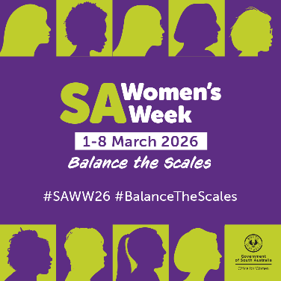 | 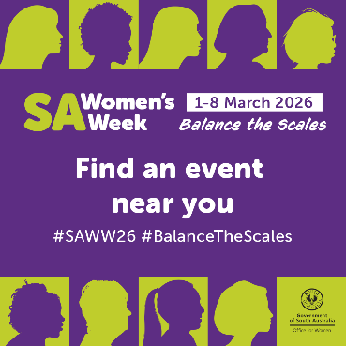
The below examples are artwork tiles specifically designed for social media.

Social media tiles – 1080 x 1350 (Instagram feed)
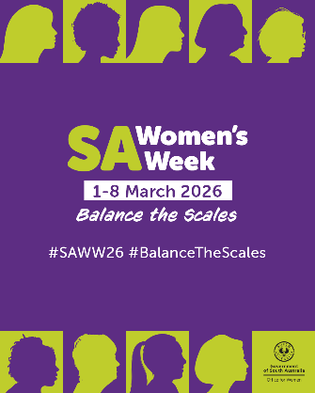 | 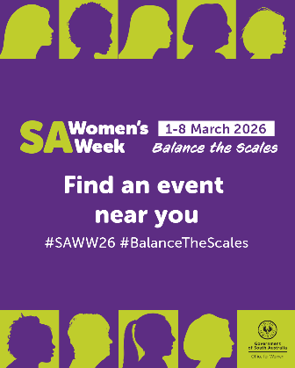

Download resources

Sample social posts
You are welcome to use the following posts on your channels as appropriate. Please feel free to adapt to your own tone and community.

Posts for lead up to SA Women’s Week
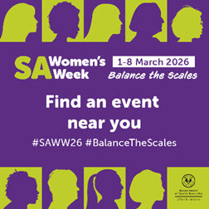
SA Women’s Week is just around the corner! Get ready to celebrate the contributions and achievements of women across South Australia from 1 to 8 March.

Join us at events across the state, celebrating the achievements of women and girls and inspiring action for gender equality. 💜💚

To register your event or find an event near you: officeforwomen.sa.gov.au/sa-womens-week

#BalanceTheScales #SAWW26

Post for 1 March 2026 – SA Women’s Week
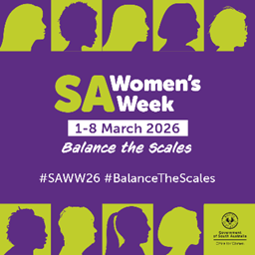
SA Women’s Week 2026 is here! 💜💚
From today to 8 March, join us as we ‘Balance the Scales’ and take action to support gender equality across South Australia.
Get involved and find an event near you: officeforwomen.sa.gov.au/sa-womens-week
#BalanceTheScales #SAWW26

Post for 8 March 2026 — International Women’s Day
Happy International Women's Day 2026!
Today, we mark the end of SA Women’s Week and celebrate the incredible achievements of women around the world to empower girls and women. Thank you to all who have got involved!
Together, we can challenge stereotypes, call out discrimination, and seek positive action to work towards gender equality.
#IWD2026 #BalanceTheScales #SAWW26

Sample newsletter article

Celebrate SA Women’s Week
SA Women’s Week is a statewide initiative to elevate the status of women and girls and create meaningful conversation, reflection and action on gender equality.
Between 1 and 8 March 2026, events will be held across South Australia to celebrate the achievements and contributions of women and girls, to spark dialogue, but most importantly to inspire everyone to take action to advance gender equality in our State.
SA Women’s Week supports this year’s UN Women Australia International Women’s Day theme, ‘Balance the Scales,’ which calls for fair, inclusive justice and freedom for all women and girls. Balancing the Scales is about making sure that every woman and girl is safe, heard and free to shape their own future.
Get involved in SA Women’s Week
There are many ways to support women and girls this SA Women’s Week:
- attend an event listed in the SA Women’s Week calendar.
- support SA Women-led Fringe shows with limited discounted tickets available during SA Women’s Week
- download the SA Women’s Week poster, print it out and spread the word within your organisation and community.
It’s time to balance the scales – take part in SA Women’s Week 2026 and help make change.



Source: Investing in Equality 2025/26 Office for Women Investing in Equality 2025 - A gender analysis of the South Australian Budget 2025-26

